Pre 8.1)

Pulse-width Modulation is a term for describing a type of digital signal. It is used in a variety of applications including sophisticated control circuity.

Duty cycle is measured in percentage. Its percentage describes the percentage of time a digital signal is on over an interval or period of time.

Pre 8.2)

1s / 50 = 20ms.



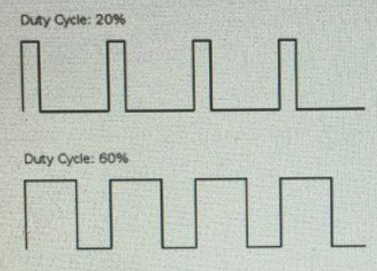

Pre 8.3)

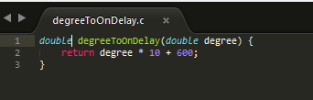

Pre 8.4)

1. Rot = degree / sec

Degree = 20 \* 10-3 / Rot

1. Degree = 20 \* 10-3 / 36 = 5.56 \* 10-4